**Name:** Soumyadeep Paul. **Anudip ID:** AF0458093

**University Roll No:** 10900321037

SQL Query 1:

CREATE DATABASE Customers;

USE Customers;

CREATE TABLE IF NOT EXISTS Customer(customer_id INT PRIMARY KEY,first_name VARCHAR(20),last_name VARCHAR(30));

INSERT INTO Customer VALUES(13, 'Roland', 'Conlin');

INSERT INTO Customer VALUES(23, 'Donald', 'Hawkings');

INSERT INTO Customer VALUES(35, 'Stephen', 'Jones');

SELECT * FROM Customer;

CREATE TABLE IF NOT EXISTS Orders(order_id BIGINT PRIMARY KEY,order_date DATE,total_amount DOUBLE,customer_id INT,FOREIGN KEY(customer_id) REFERENCES Customer(customer_id));

INSERT INTO Orders VALUES(494503, '2016-03-14', 450.00, 13);

INSERT INTO Orders VALUES(494504, '2016-03-14', 350.00, 23);

INSERT INTO Orders VALUES(494505, '2016-03-14', 150.00, 35);

SELECT * FROM Orders;

# Perform Inner Join

SELECT Customer.first_name, Customer.last_name, Orders.order_date, Orders.total_amount

FROM Customer

INNER JOIN Orders ON Customer.customer_id = Orders.customer_id;

**RESULTS:**

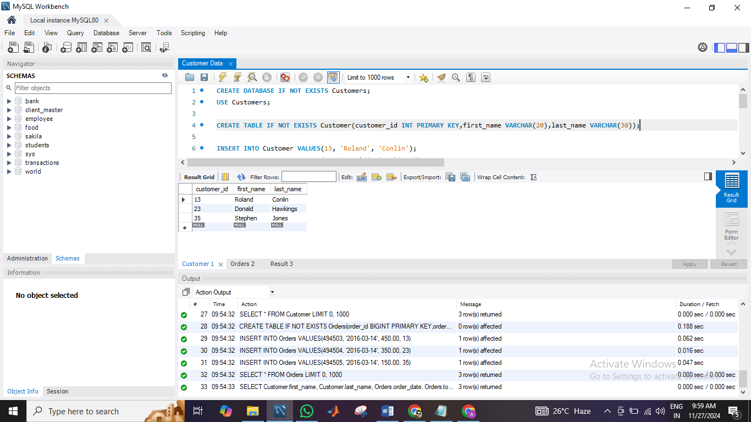

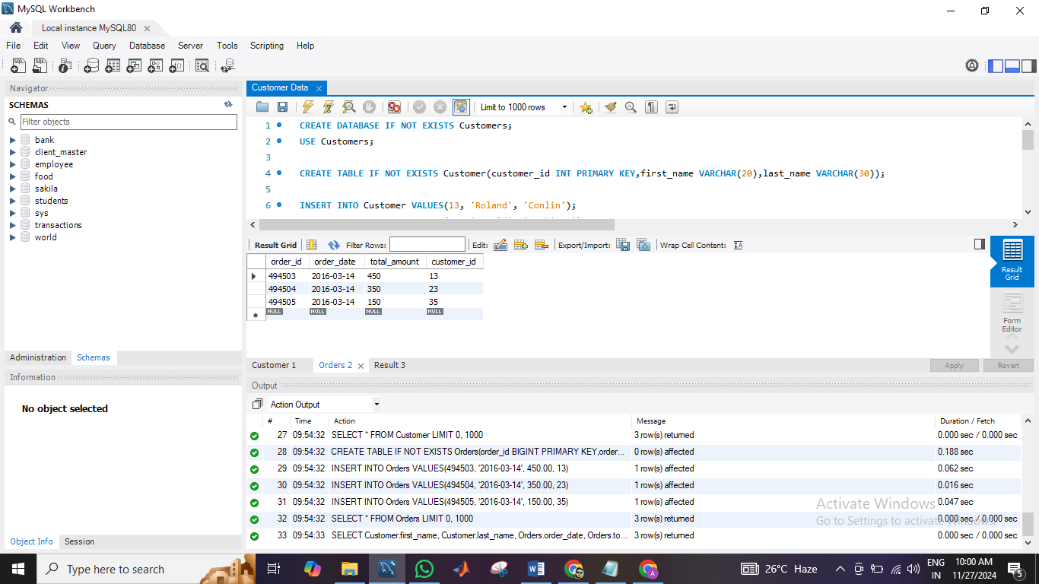

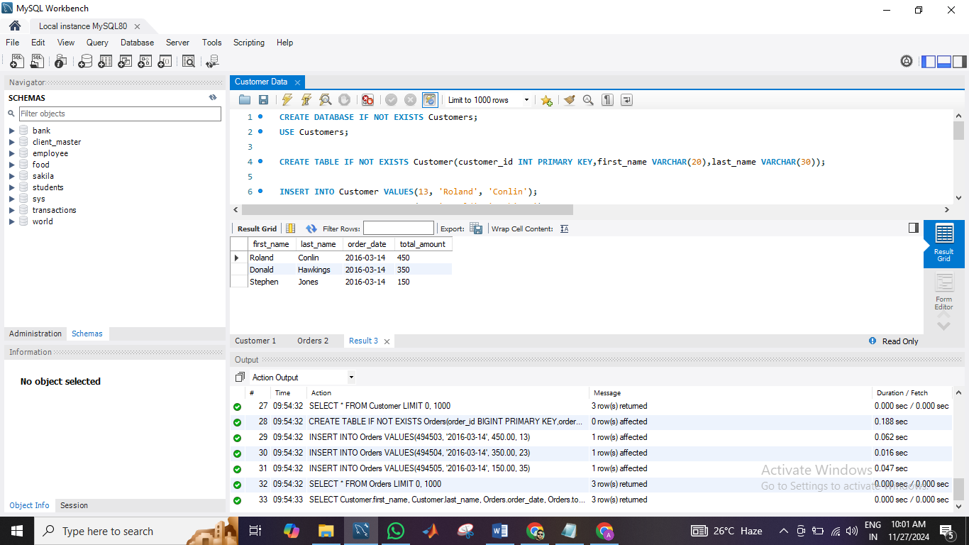

SQL Query 2:

CREATE DATABASE CompanyDB;

USE CompanyDB;

# Create Department Table

CREATE TABLE Department (department_id INT PRIMARY KEY,department_name VARCHAR(30));

INSERT INTO Department VALUES(1, 'Human Resources');

INSERT INTO Department VALUES(2, 'Finance');

INSERT INTO Department VALUES(3, 'IT');

INSERT INTO Department VALUES(4, 'Marketing');

# Create Employees Table

CREATE TABLE Employees (employee_id INT PRIMARY KEY,first_name VARCHAR(30),last_name VARCHAR(30),department_id INT,FOREIGN KEY (department_id) REFERENCES Department(department_id));

INSERT INTO Employees VALUES(101, 'John', 'Doe', 1);

INSERT INTO Employees VALUES(102, 'Jane', 'Smith', 2);

INSERT INTO Employees VALUES(103, 'Michael', 'Johnson', 3);

# Perform Left Join

SELECT Department.department_name, Employees.first_name, Employees.last_name

FROM Department

LEFT JOIN Employees ON Department.department_id = Employees.department_id;

**RESULTS:**

